Shocking and Thumbless Grace
Judges 1:1-7

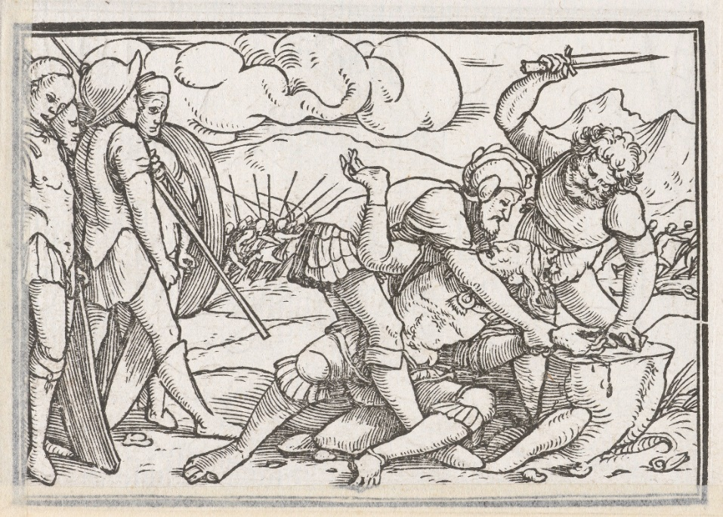
“The most shocking feature in the book of Judges is not the horror of the people’s sin depicted in these narratives but the glory of salvation from that sin, accomplished by the God of patience, mercy, compassion, steadfast love, and faithfulness. The terror of sin is outshone only by the glory of God’s salvation worked through these judges, who then point us to Jesus Christ.” ~Miles Van Pelt

1. Re-read Judges 1:1-7. Do you have any questions or comments about the sermon or the passage? What is Jesus teaching you through Judges?

2. How does the New Testament help you understand the book of Judges? (See Romans 1:1-3) Why do Christians need these Old Testament stories?

3. Understanding our sin: Adoni-Bezek makes the claim of being a world-conquering king, cutting off the thumbs and big toes of 70 kings and treating them like dogs. What is his sinful boast? How does this boast affect how he treats other people? Who else in the Bible claims falsely to be a world-conquering king? (Hint: Matthew 4:8-10) What ought we confess?

4. Understanding our shocking salvation: Adoni-Bezek, the world-conquering king, had to be defeated and put to open shame (bye-bye thumbs) and die in Jerusalem for his sins. Jesus, in order to take His given inheritance, the nations (us- Psalm 2:8-9), had to defeat the ruler of this world, whose team we were on (Ephesians 2:1-2). How should Jesus, the Lion of the tribe of Judah, treat His enemies? What must happen for you and I to receive our gospel inheritance from God the Father? How does this kill our boasting? What boasting do you need to kill? Where are you tempted to scream, “mine!” and resort to thumb-chopping humiliation and control?

5. Take time to pray together for the Holy Spirit to help kill our boasting and to incline your heart to follow Jesus, the Lion of the tribe of Judah who conquers this world as a Lamb.

